SALES_ORDERS LAD : (RESULT AND SAMPLE NUMBERS)

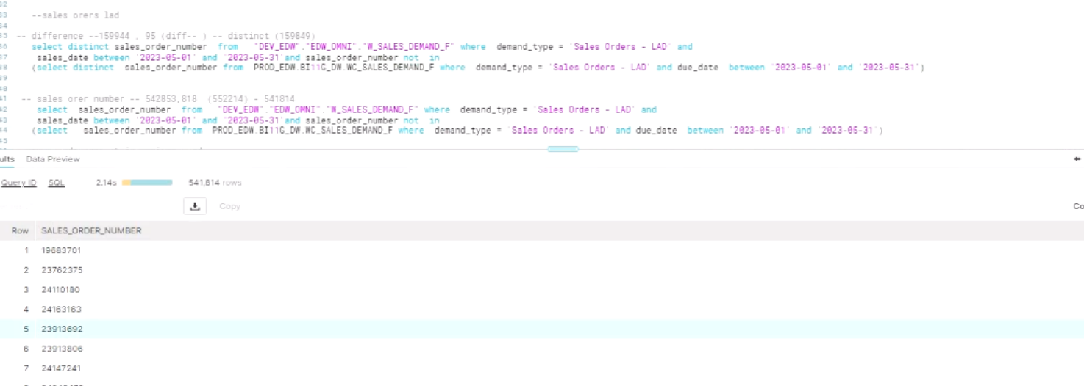

Row

SALES_ORDER_NUMBER

1

19683701

2

23762375

3

24110180

4

24163163

5

23913692

6

23913806

7

24147241

8

24048479

9

24040197

10

24080634

11

24093382

12

24200600

13

24039718

14

24079586

15

24078353

16

24150652

17

24113925

18

24084468

19

24130172

20

24180051

CODE WITHOUT JOIN (FOR ITEMCOST AN OTHER 4 COLS)

1. Checking for the data in omni and not in prod
2. Query to check the data that is present in omni and not in prod
3. Query to check the data that is present in prod and not in omni
4. Check those records why missing in prod by checking in omni and its source
5. Example for this source number a. 24180088

Case study:

Total no of records in omni : 30(unscheduled, sales order lad)

Total no of records in prod : 80 (sales order lad (15), sales orders (15), comsumption (50)

Query to check for the consumption record:

-- consumption stage

with

plan_demand as (select * from dev_discover.SUPPLY_CHAIN.stg_oracle__planned_demand),

supply_chain_plans as (

select * from dev_discover.SUPPLY_CHAIN.stg_oracle__supply_chain_plans

),

organization_plan as (select * from dev_discover.SUPPLY_CHAIN.stg_oracle__organization_plans),

msc_system as (select * from dev_ods.oracle_scp.msc_system_items),

msd_dp_scn as (

select * from dev_ods.oracle_scp.msd_dp_scn_entries_denorm

),

consumed_demand as (select * from dev_discover.SUPPLY_CHAIN.stg_oracle__consumed_demand),

order_details as (select * from dev_discover.ORDER_MGMT.stg_oracle__order_details),

mtl_uom_conv as (select * from dev_discover.MASTER_DATA.stg_oracle__item_uom_conversions),

shipped_demand as (select * from dev_discover.SUPPLY_CHAIN.stg_oracle__shipped_demand),

item_safety_stocks as (

select * from dev_discover.SUPPLY_CHAIN.stg_oracle__item_saftey_stocks

)

select * from

supply_chain_plans inner join msc_system

on supply_chain_plans.plan_id = msc_system.plan_id

inner join consumed_demand

on supply_chain_plans.plan_id = consumed_demand.plan_id

and msc_system.inventory_item_id = consumed_demand.inventory_item_id

and msc_system.organization_id = consumed_demand.organization_id

inner join organization_plan

on organization_plan.plan_id = consumed_demand.plan_id

and organization_plan.organization_id = consumed_demand.organization_id

and organization_plan.sr_instance_id = consumed_demand.sr_instance_id

and (consumed_demand.consumed_qty > 0)

and consumed_demand.sales_order_number = '24180088'

Query to query in ods table(not present)

select * from dev_ods.oracle_scp.msc_forecast_updates where sales_order_number = '24180088'

Query to check in prod and dev_omni

---present in omni and not in prod (15)

select sales_order_number from "DEV_E

sales_date between '2023-06-01' and

(select sales_order_number from P

-- present in omni and prod (15)

select sales_order_number from "

sales_date between '2023-06-01' and

(select sales_order_number from P

-- present in prod not in omni (50)

select sales_order_number,DEMAND_TYP

due_date between '2023-06-01' and '2

(select sales_order_number from "D

-- present inprod not in omni (15)

select sales_order_number,DEMAND_TYPE

due_date between '2023-06-01' and '2

(select sales_order_number from "D

and sales_order_number = '24180088')

-- ptesent in prod not in omni (15)

select sales_order_number,DEMAND_TY

due_date between '2023-06-01' and '2

(select sales_order_number from "D

and sales_order_number = '24180088')

-- at the end 80 in prod and 30 in omni (captured for JUNE 2023)

For demand_type (forecast)

1. select sales_order_number,demand_type from"DEV_EDW"."EDW_OMNI"."W_SALES_DEMAND_F" where demand_type = 'Forecast' and sales_date between '2023-06-01' and '2023-06-30' (119,221)
2. select sales_order_number,demand_type from PROD_EDW.BI11G_DW.WC_SALES_DEMAND_F where demand_type = 'Forecast' and due_date between '2023-06-01' and '2023-06-30' (58269)

query to find out the records (NULL) for forecast in msc demands join

---- planned_demand (msc_demands)

with

plan_demand as (select * from dev_discover.SUPPLY_CHAIN.stg_oracle__planned_demand),

supply_chain_plans as (

select * from dev_discover.SUPPLY_CHAIN.stg_oracle__supply_chain_plans

),

organization_plan as (select * from dev_discover.SUPPLY_CHAIN.stg_oracle__organization_plans),

msc_system as (select * from dev_ods.oracle_scp.msc_system_items),

msd_dp_scn as (

select * from dev_ods.oracle_scp.msd_dp_scn_entries_denorm

),

consumed_demand as (select * from dev_discover.SUPPLY_CHAIN.stg_oracle__consumed_demand),

order_details as (select * from dev_discover.ORDER_MGMT.stg_oracle__order_details),

mtl_uom_conv as (select * from dev_discover.MASTER_DATA.stg_oracle__item_uom_conversions),

shipped_demand as (select * from dev_discover.SUPPLY_CHAIN.stg_oracle__shipped_demand),

item_safety_stocks as (

select * from dev_discover.SUPPLY_CHAIN.stg_oracle__item_saftey_stocks

),

weekly_forecasted_orgs as (

SELECT distinct sr_organization_id as sr_organization_id,'Y' AS weekly_flag

FROM msd_dp_scn

WHERE start_time >=(current_date()-365)

AND BUCKET_TYPE =2

)

select *

from plan_demand left outer join weekly_forecasted_orgs

on plan_demand.organization_id = weekly_forecasted_orgs.sr_organization_id

inner join msc_system

on msc_system.sr_instance_id = plan_demand.sr_instance_id

and msc_system.inventory_item_id = plan_demand.inventory_item_id

and msc_system.organization_id = plan_demand.organization_id

and msc_system.plan_id = plan_demand.plan_id

inner join supply_chain_plans

on supply_chain_plans.plan_id = plan_demand.plan_id

inner join organization_plan

on organization_plan.plan_id = plan_demand.plan_id

and organization_plan.organization_id = plan_demand.organization_id

and organization_plan.sr_instance_id = plan_demand.sr_instance_id

and plan_demand.order_number is NULL and plan_demand.demand_source = 'Forecast'

and plan_demand.using_assembly_demand_date between '2023-06-01' and '2023-06-30'

in unschdule

23904442